Bibliografía de factores de atenuación de la

precipitación en función del área de la cuenca

1. Manual on estimation of probable maximum precipitation (PMP) - WMO-No. 1045 año 2009 2

Statistical estimates, area-reduction curves. 2

Generalized estimates - estimates for orographic regions – PMP, Colorado River 3

Generalized estimates - estimates for orographic regions, Pacific North-West USA 5

Generalized estimates - estimates for orographic regions – PMP, California USA 6

Estimates for tropical regions - PMP estimates for Individual Regions 7

2. Manual for estimation of probable maximum precipitation - WMO No. 332 – 1986 9

Area-reduction curves (4.2.5) 9

Time distribution of rainfall (5.3.2.7) 11

Depth-area relation (5.3.7.5) 12

Mean seasonal precipitation map (6.2.2.1) 13

# 1. Manual on estimation of probable maximum precipitation (PMP) - WMO-No. 1045 año 2009

## Statistical estimates, area-reduction curves.

Page 69. (4.2.5)

The procedure described here was developed for point rainfall data. Hence, its use requires some method for reducing the point values it yields to some required areal rainfall averages. There are two types of depth–area relations (Miller and others, 1973). The first is the storm-centred relation, that is, the maximum precipitation occurring when the storm is centred on the area affected (Figure 4.6A). The second type is the geographically fixed area relation where the area is fixed and the storm is either centred on it or displaced so only a portion of the storm affects the area (Figure 4.6B). Storm-centred depth–area curves represent profiles of discrete storms, whereas the fixed-area data are statistical averages in which the maximum point values frequently come from different storms. The storm-centred curves are appropriate for use with PMP studies.

There are many variations of the two basic depth–area relations (Court, 1961; United States Weather Bureau, 1960). Those for use with any PMP studies should be based on the depth–area–duration (DAD) characteristics of the storms types capable of producing the PMP in the region. The curves of Figure 4.7 are based on average values obtained from DAD analyses of important general storms over the western United States. The relation of Figure 4.7 is presented only as an idealized example and curves should be developed for the specific location of the project. For example, this relation does not show as much decrease with increasing area as would curves based on localized cloudbursts, and is therefore inappropriate for use where such storms would cause the PMP. They do not extend beyond 1 000 km2 because extrapolation of point rainfall values becomes more unreliable as size of area increases. Necessity, however, has led to relations (McKay, 1965) relating point values to areas in excess of 100 000 km2. Point values are often assumed to be applicable to areas up to 25 km2 without reduction.

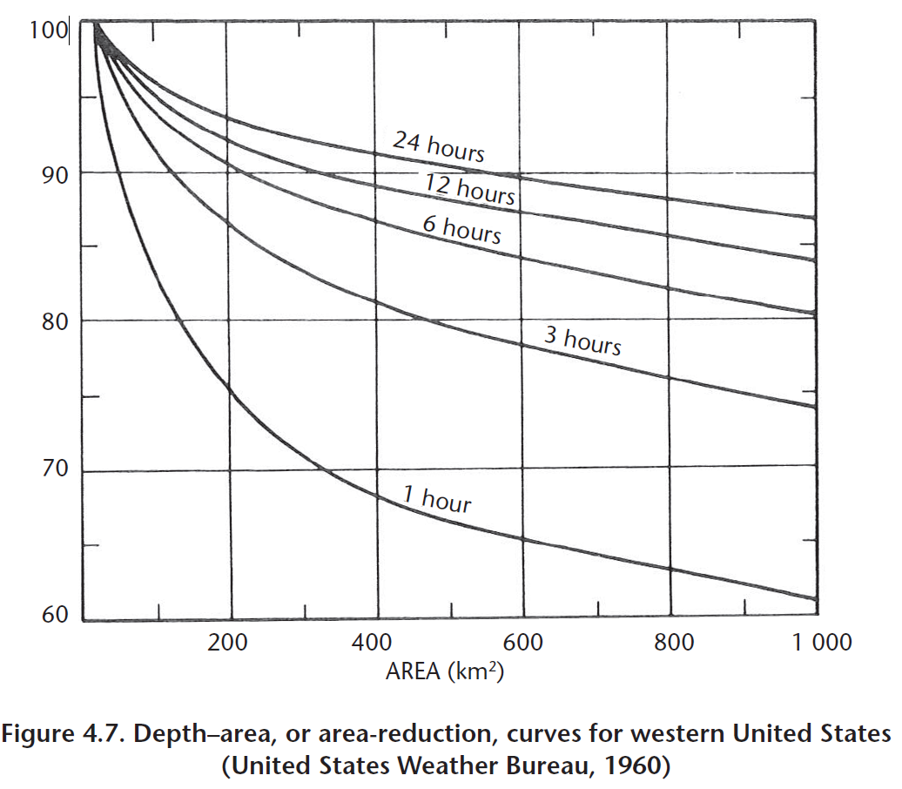

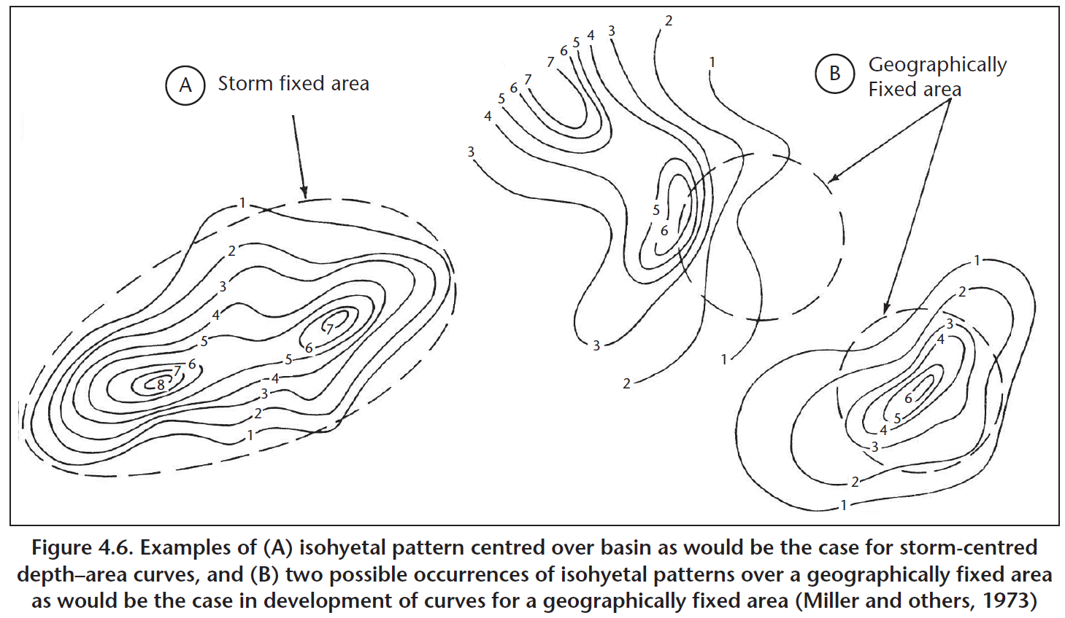

## Generalized estimates - estimates for orographic regions – PMP, Colorado River

Page 108.

Estimates for the Colorado River and Great Basin drainages of the south-western United States - 5.3.5.1.1 Modifications of the first approximation to the orographic precipitation index Several factors were used to provide guidance in modifying the first approximation to the orographic PMP index. The first of these were rain ratios for line segments across ridges in the region. The rain ratio is the rate of change in rainfall per 305 m divided by the base elevation rainfall. This rain ratio is one index to the variation of rainfall with elevation and is related to the low-elevation amounts. Various rain ratios were computed based on the 100-year 24-hour rainfall, mean annual precipitation, mean seasonal precipitation, and maximum observed values. A modification of this rain ratio was based upon mean monthly rainfalls adjusted by a frequency of rain versus elevation relation.

This ratio was not greatly different from, but generally slightly smaller than, rain ratios not adjusted by the frequency of rainfall relations. Rain ratio profiles were also computed for several major storms in the region. As a basis for a comparison, all ratios were plotted on graphs, using distance from the ridge for the x-coordinate Also plotted on the graphs were the terrain profiles. Similar ratios were also computed for the region beyond the ridge to the valley on the lee side. Using this information, the region was divided into three separate terrain categories: (a) most orographic; (b) least orographic; and (c) intermediate orographic. In the areas of most orographic effects, the gradient of PMP was maintained at about twice the gradient in the rain ratios of 100-year 24-hour rainfall and mean annual precipitation. In the least orographic regions, orographic PMP had a lower limit of 25.4 mm. Orographic rainfall in these regions is attributed to either spillover from upwind regions or the generalized influence of smaller hills that make up a part of most areas classified as least orographic. In intermediate orographic areas, isoline gradient was maintained at about the same as for the rainfall ratios. Figure 5.39 shows a portion of the orographic index PMP map for southern Arizona, south-western New Mexico and south-eastern California.

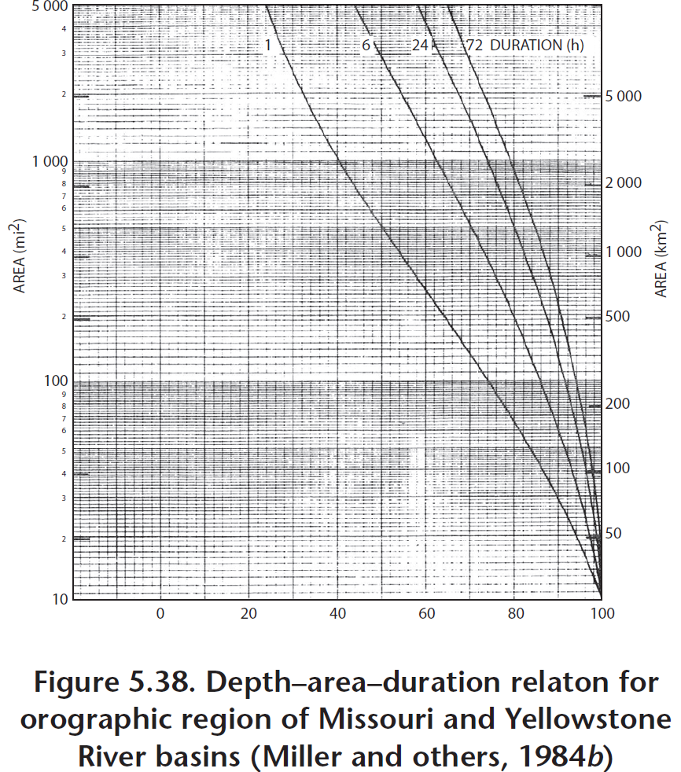

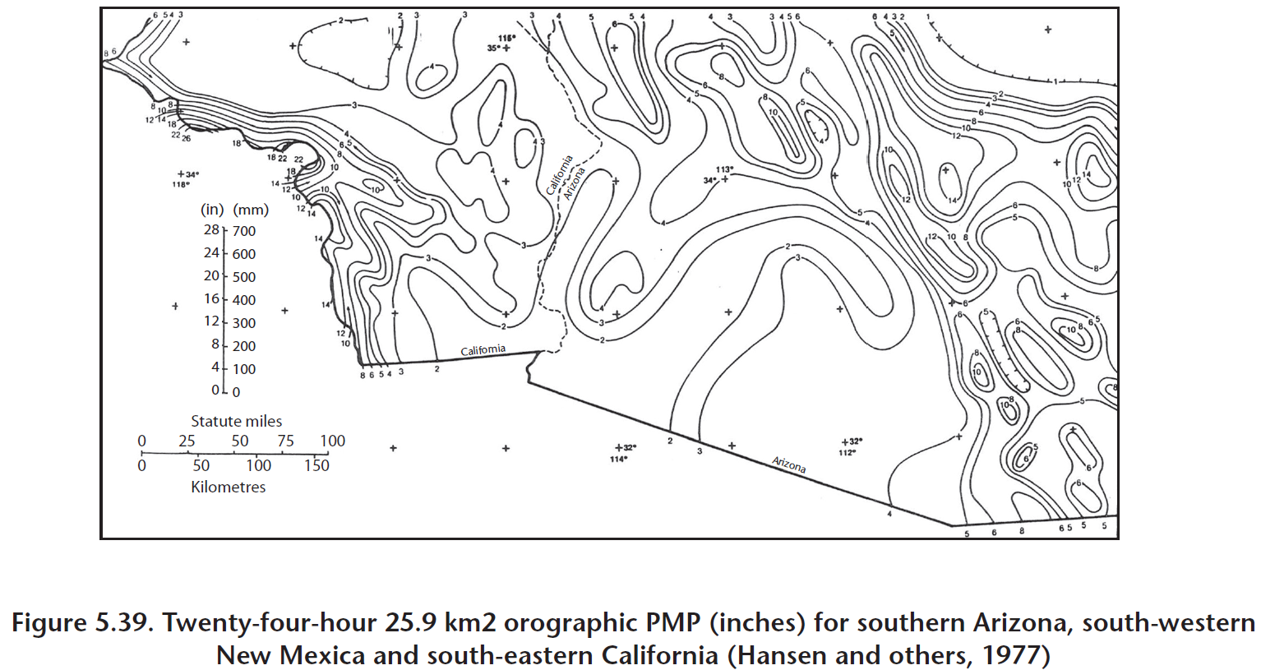

## Generalized estimates - estimates for orographic regions, Pacific North-West USA

Page 113.

Generalized estimation of PMP for local storms in the Pacific North-west region of the United States - (5.3.7.5) PMP precipitation depth–area relation - Based on HMR No. 43 (United States Weather Bureau, 1966) and HMR No. 49 (Hansen and others, 1977) and studies of data on extreme local storms in the North-west region, the precipitation depth–area relation has been corrected. The current precipitation depth–area relation is shown in Figure 5.43. The adopted generalized local storm isohyetal map is shown in Figure 5.44. Using both of these, the spatial distribution of PMP of local storms with particular durations and areas may be determined.

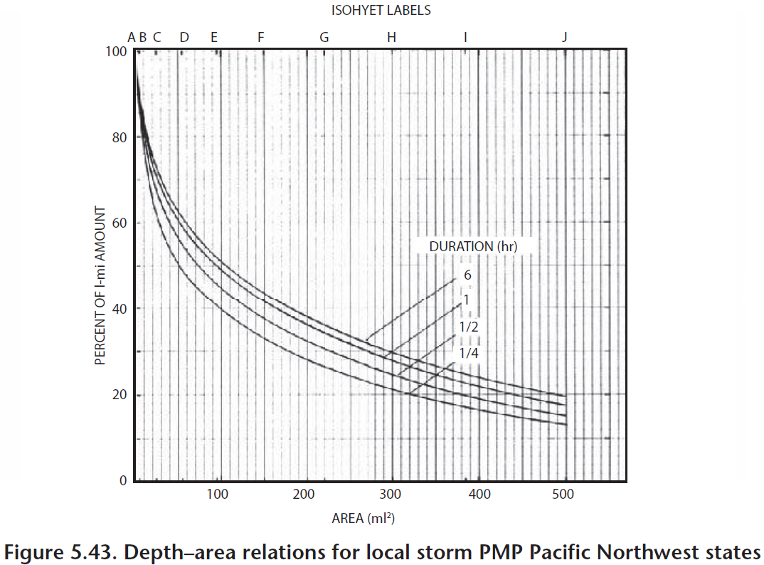

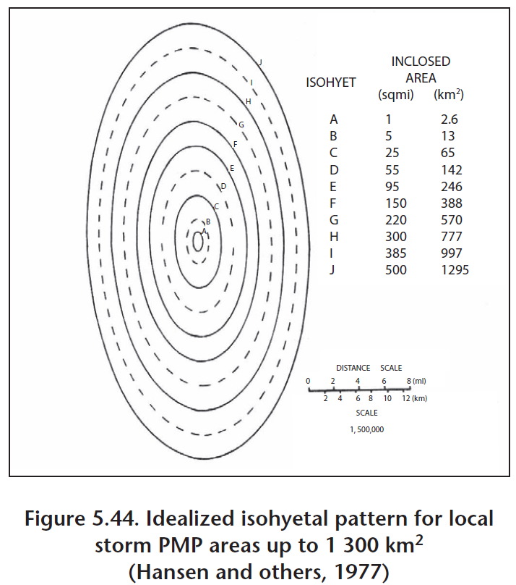

## Generalized estimates - estimates for orographic regions – PMP, California USA

Page 122.

Estimation in California, United States - Procedure and example computation of estimating PMP with the local storm method - Correction for watershed area size is performed using figures available for the coefficients of area reduction (area size < 1 295 km2) for corrections of types A, B, C and D. Figure 5.56 presents the coefficients of area reduction corresponding to corrections of type C. The coefficient of area reduction for a storm area of 432 km2 converted from 2.6 km2 is obtained from Figure 5.56 (in fact, the coefficient is unrelated to the watershed area size and is related only to the ratio of 6-hour PMP to 1-hour PMP). The PMP for the corresponding duration in (c) is multiplied by the coefficient to get the PMP with correction for watershed area size (see Table 5.19).

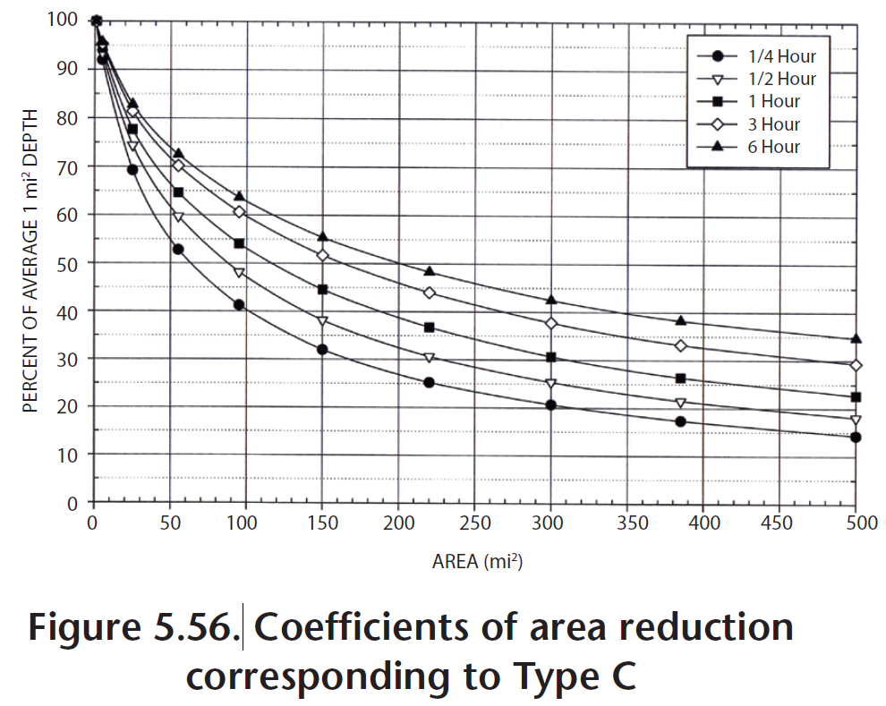

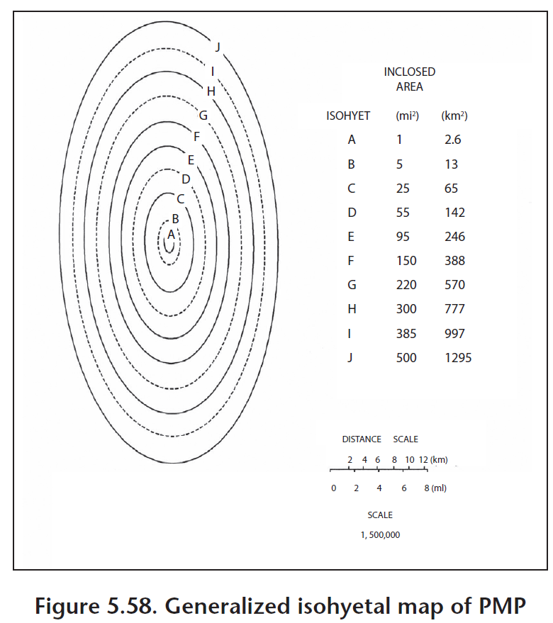

## Estimates for tropical regions - PMP estimates for Individual Regions

Page 153. (6.2.1.3)

Generalized PMP estimates - Generalized estimates of 24-hour point (2.6 km2) PMP are presented in Figure 5.1. Climatological data showing spillover and other orographic effects were used to modify the results indicated by the relation in Figure 6.5. Ratios of PMP to 100-year rainfall were examined and adjustments made to avoid unrealistically high or low ratios. DAD relations (Figure 6.6) for extending the basic PMP values to durations of 30 minutes–24 hours and to areas up to 500 km2 were derived mainly from Hawaiian storms. No seasonal variation curve was required since the greater efficiency and lower moisture of cool season storms balanced the lower efficiency and greater moisture of summer season storms. PMP for a specific basin is obtained by planimetering the area within the basin on the 24-hour point PMP chart (Figure 5.1) to obtain the 24-hour basin-average PMP. The DAD relation from Figure 6.6 is then used to obtain PMP values for other durations.

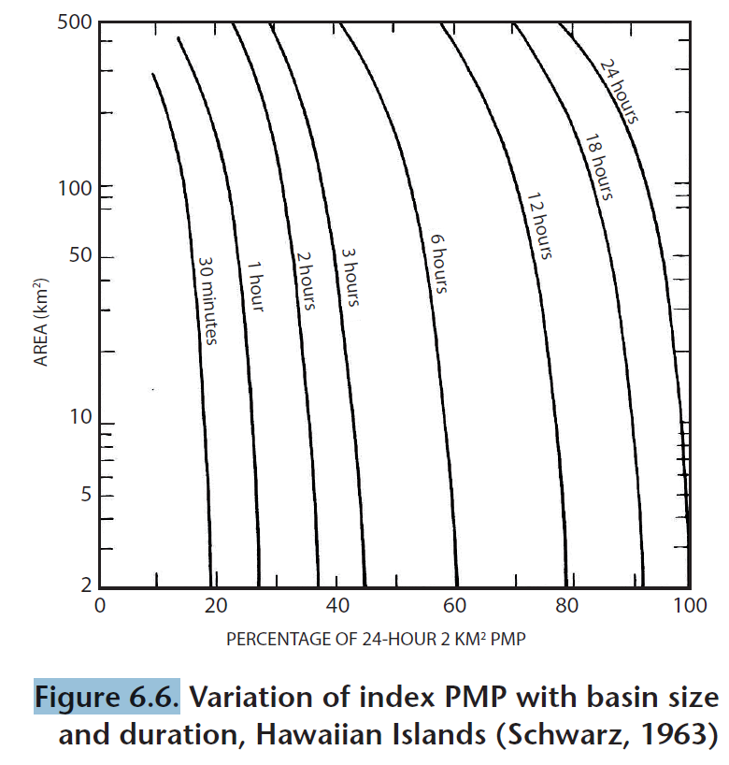

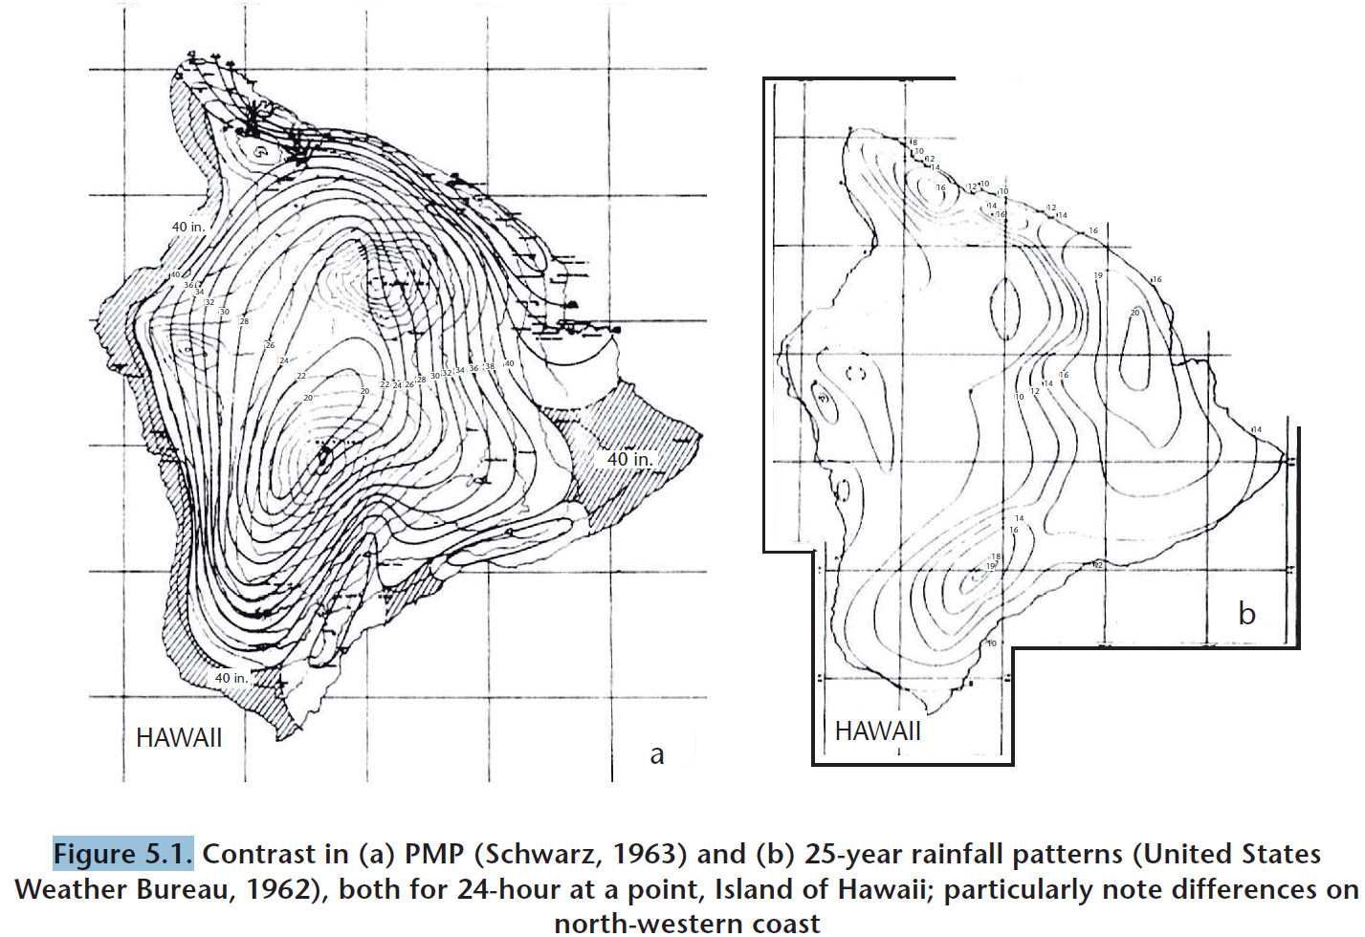

# 2. Manual for estimation of probable maximum precipitation - WMO No. 332 – 1986

## Area-reduction curves (4.2.5)

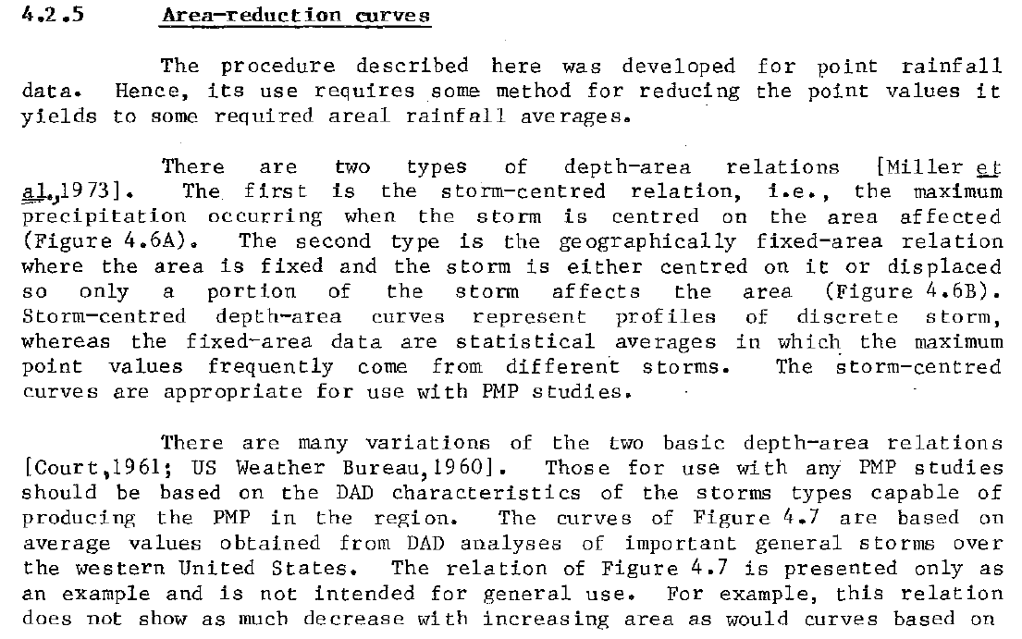

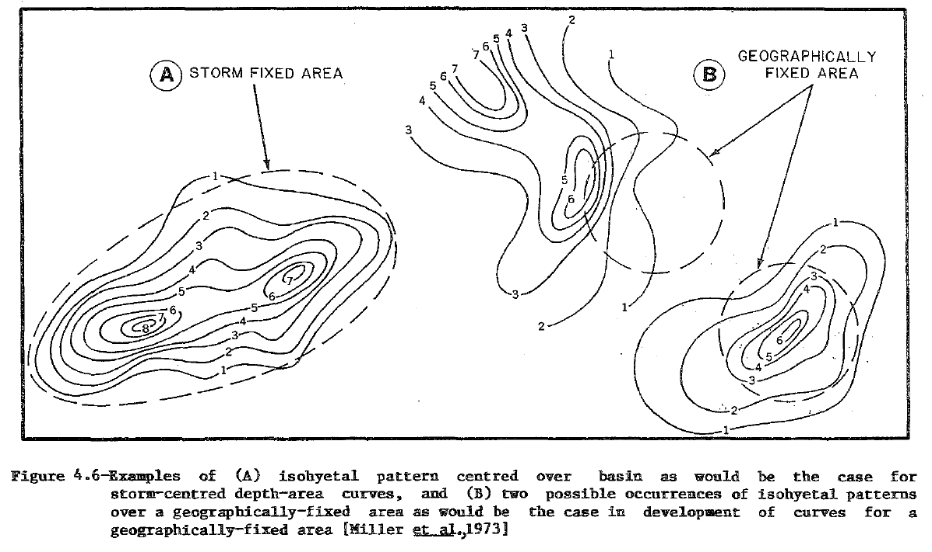

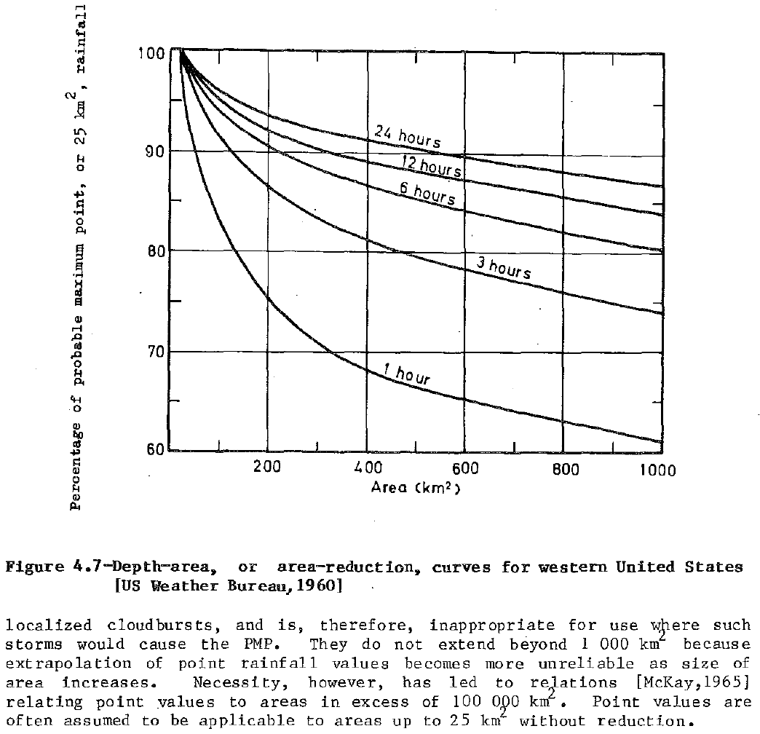

## Time distribution of rainfall (5.3.2.7)

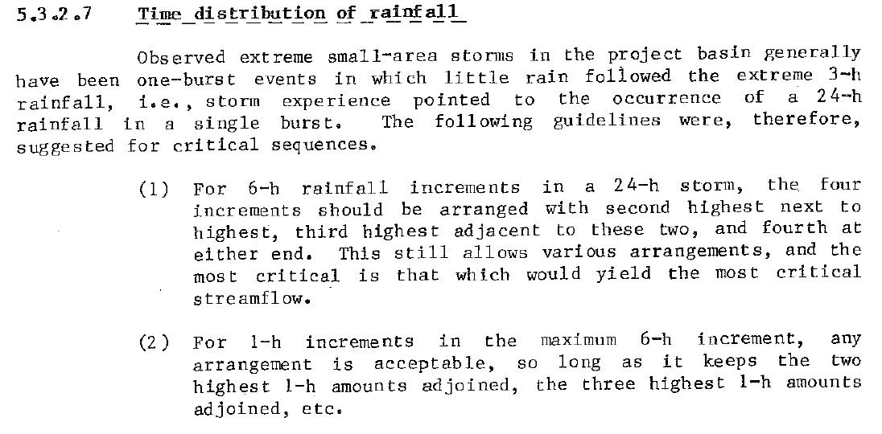

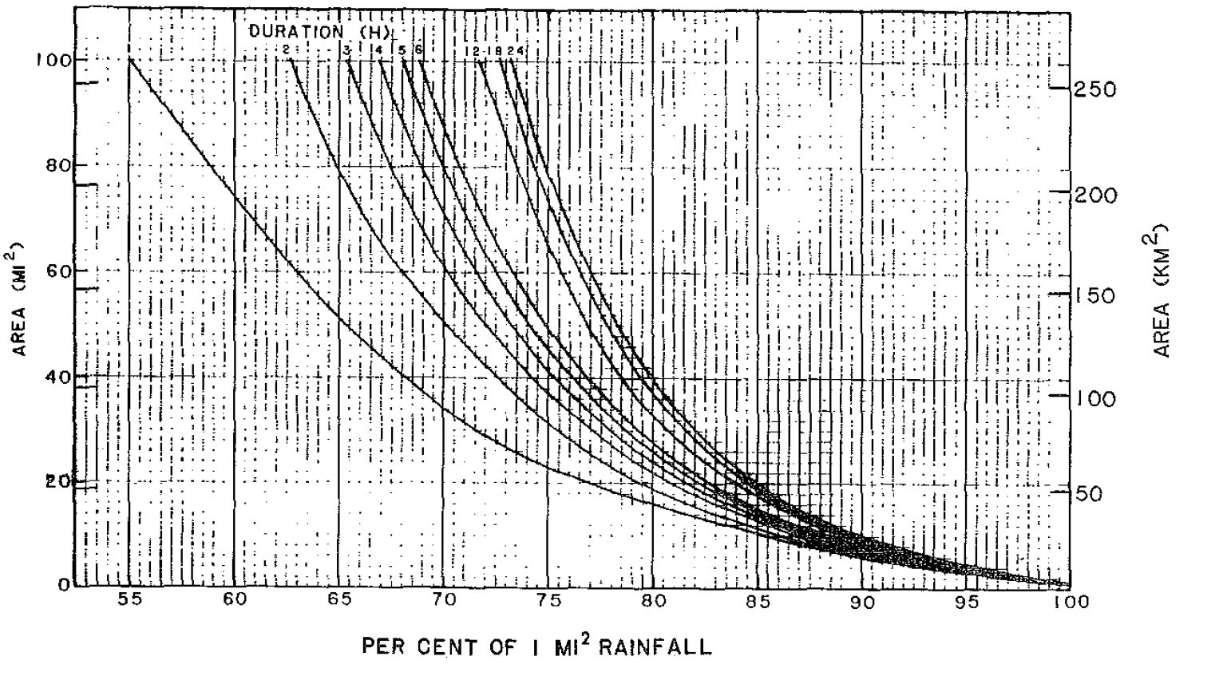

## Depth-area relation (5.3.7.5)

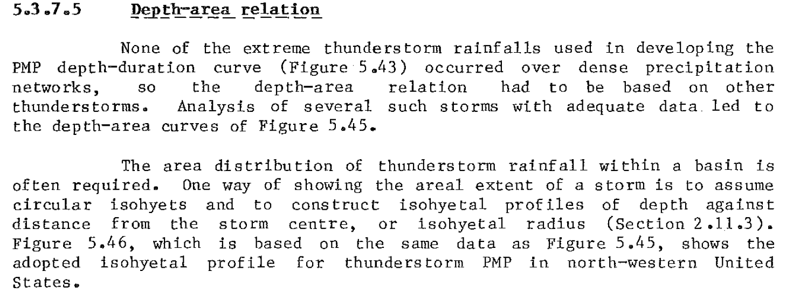

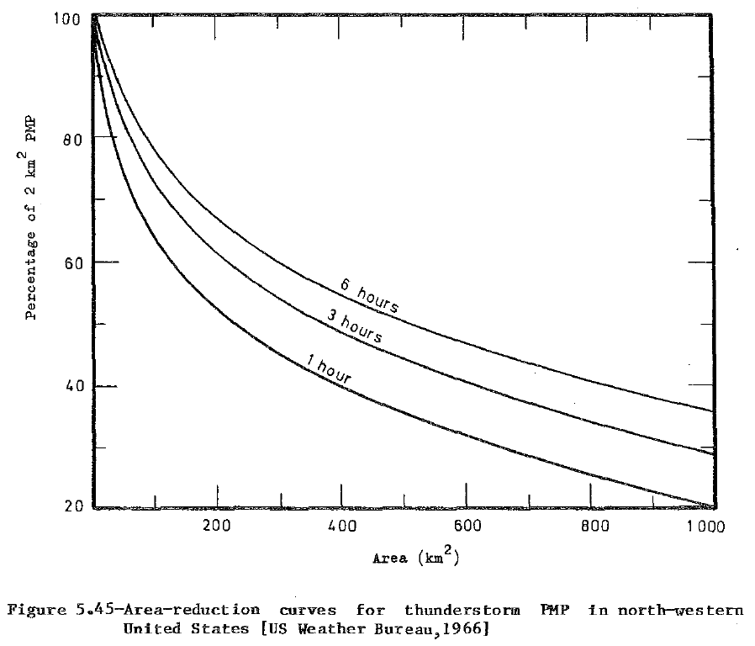

## Mean seasonal precipitation map (6.2.2.1)

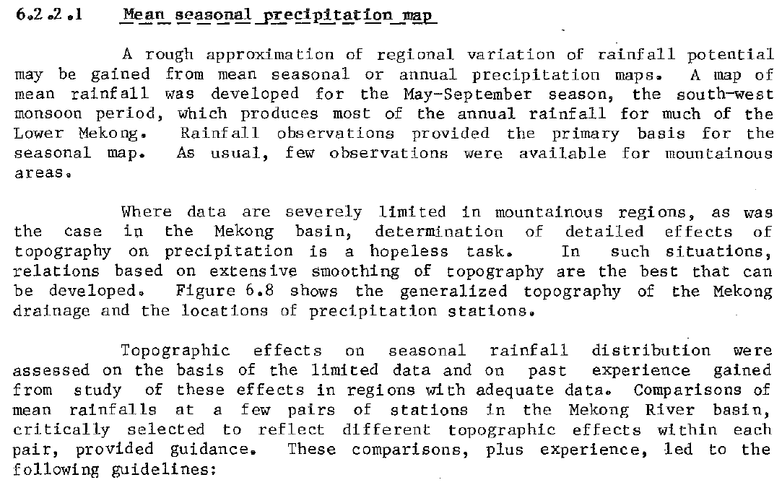

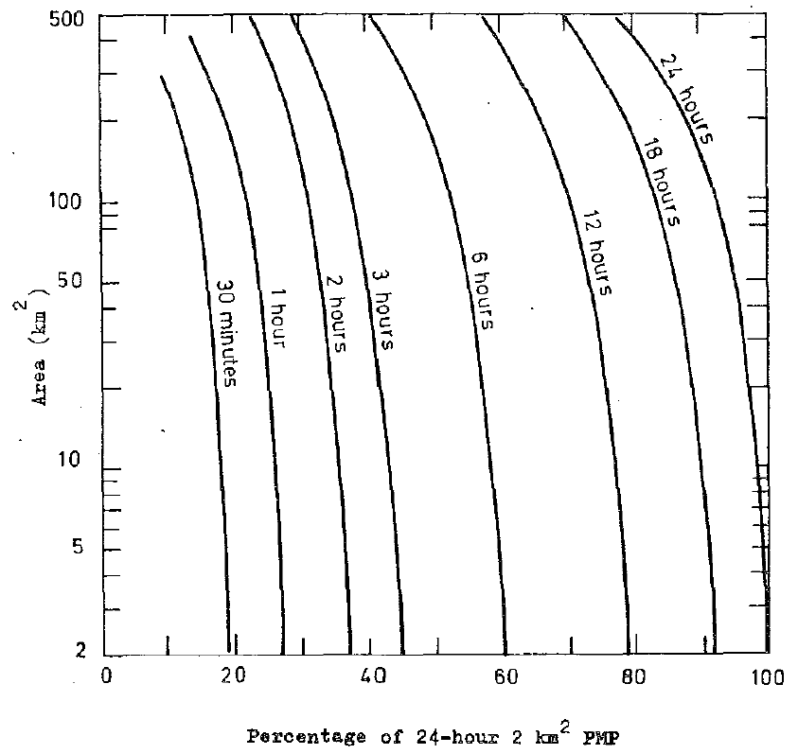

<https://github.com/rcfdtools/R.HydroTools/tree/main/FactorAtenuacionPrecipitacionFa>